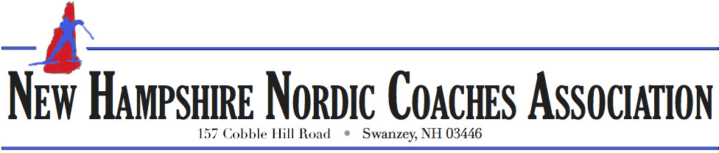
Competition and Rules for Selection of Team to Represent New Hampshire
at NENSA’s U16 and Eastern High School Championships

Section 1: Governing Body

The New Hampshire Nordic Coaches Association is the organization of coaches recognized by NENSA as the body that selects the team of high school aged skiers, up to 24 boys and 24 girls, to represent the state of New Hampshire at the NENSA U16 and Eastern High School Championships (hereinafter TEAMNH)

As stated in the New Hampshire Nordic Coaches’ Association Bylaws: The sole purpose of the Corporation will be to perform services of public good and welfare to advance the development of BKL, middle and high school Nordic skiers of all abilities, through education and support of competitive Nordic racing programs in the state which shall include, but not be limited to, organization, management and financial support of those athletes selected to represent New Hampshire in regional Nordic competition.

Section 2: TEAMNH Eligibility

In accordance with NENSA eligibility requirements, equal access to the selection process for TEAMNH is provided to all candidates who meet the following criteria:
  - U16: The candidate must have celebrated their 14th or 15th birthday in the year directly preceding the year of the competition.
  - EHSC: The candidate is a high school student (9th-12th grade: public, private, or homeschooled)
  - U16 & EHSC: The candidate either maintains permanent residence in New Hampshire or attends school in New Hampshire

Section 3: Competition – NHNCA Race Series

The NHNCA conducts two statewide races each year. These races consist of six fields:
High School Boys A Race, High School Girls A Race, Middle School Boys Race, Middle School Girls Race, High School Boys B Race, High School Girls B Race.

Section 4: Establishing NHNCA Standings

NHNCA Standings Committee: A committee of three individuals will be responsible for determining the NHNCA Standings. This committee shall consist of Team Leaders for TEAMNH (U16 Team Leader and EHSC Team Leader) as well as one additional coach from the membership of the NHNCA, to be appointed by the president of the NHNCA prior to the first NHNCA Series Race of the season.

Baseline Standings: Baseline NHNCA Standings will be calculated using both average placing and average percent back calculations, based upon results for the NHNCA Race Series.

  - U16 Standings – These standings are compiled from the skiers born in the appropriate calendar year window, across all fields of competition.
  - EHSC Standings – These standings are compiled from skiers who compete in the High School A races, which are the premier events of the NHNCA Race Series.

Revised Standings: Athletes who meet the NENSA eligibility requirements (See Section 2: Eligibility), but did not participate in an NHNCA Race Series event (See Section 3: Competition-NHNCA Race Series), may be considered for inclusion in the NHNCA Standings upon the filing of a petition to the NHNCA Standings Committee.

Eligibility: Any athlete who has registered for the NH Series and is unable to attend a NHNCA Race Series event due to severe illness, family emergency, or other extenuating circumstances (including, but not limited to, participation on NENSA sponsored teams or events used for Junior National qualifiers) may submit a petition to be considered for inclusion in the NHNCA Standings.

Process:

- Athlete Submission: Athletes filing a petition to request inclusion in the NHNCA Standings will provide the following information. For the first NHNCA Series Race, this submission must occur within six calendar days (inclusive) of the missed race. For the second NHNCA Series Race, this submission must be submitted prior to the start of racing for the second race.
  - A brief explanation of why the athlete did not attend the NHNCA Race Series event in question.
  - Results from a comparable time period that indicate(s) where the athlete would have likely finished in the NHNCA Race Series event in question. For example, if a Classic race were missed then race results from a classic race of similar length within the current season with competitors who also attended the NHNCA Classic race could be offered as evidence for ranking purposes.
  - An endorsement from the athlete’s coach.
- Consideration by NHNCA Standings Committee: The NHNCA Standings Committee will make a final decision as to where in the NHNCA Standings petitioning athletes should be placed for the events in question. This decision will be reported back to the athlete who filed the petition and the coach who endorsed the petition.
In the event that one of the NHNCA Coaches Series Races has to be canceled, the NHNCA Standings will be established based solely on the results from the NHNCA Series Race that took place and the consideration of the associated petitions filed as indicated above.

Section 5: Selection and Naming of TEAMNH

TEAMNH will be selected based upon the Revised NHNCA Standings, determined as indicated in Section 4 above. The team will consist of 24 boys and 24 girls as well as 5 alternates for each gender, for each portion of the team (U16 and EHSC).

TEAMNH will be named at the awards ceremony for the second NH Series race.

In the event the second race is canceled, the team will be named virtually through the website and via e-mail to coaches.

Named athletes must accept or decline an offer to participate on TEAMNH within 72 hours of their coaches receiving notification of the offer. Athletes who fail to meet that time requirement will be considered automatic declines.

Positions on TEAMNH that are not accepted will be filled by proceeding down the Revised NHNCA Standings.

Subsequent additions to TEAMNH will be informed through direct communication to affected athletes and their coaches, by the respective team leader.

In the event that it is necessary to fill a vacancy on TEAMNH due to sudden illness or other extenuating circumstances, suitable replacements will be selected at the discretion of the team leader for TEAMNH.

